Due: 08th October 2015

Keith Byrne &Liam Strevens

Institute of technology Carlow

Computer Science Research Project Specification

Scrabble Engine

Table of Contents

Purpose and Goals 2

Project Strategy 2

Research Methodologies 2

Quantitative 3

Qualitative 3

Scope 4

Project Assumptions 4

Project Constraints 4

Project Boundaries 4

Project Scope Description 4

Game Scope 4

Search and Score Scope 4

Deliverables 5

Strategic Deliverable (1) 5

Operation Deliverables (3) 5

Functional Interfaces 5

Functional Interface (External) 6

Functional Interface (Internal) 6

Standards (Specific to Project) 6

C# / .NET Framework Development Standards 6

Data Modelling Standards & Normalisation 7

Game Rules Standards 7

References 8

Table of Figures 8

# Purpose and Goals

Scrabble is a word based game that is played by two or more players, typically with a maximum of 4 to 6, depending on the allocation of character tiles. The basic constraints involved in Scrabble are that entries must be played on the 15x15 grid play area and flow left to right as rows or downwards as columns and entries must be valid Scrabble words, not including nouns.

To construct a system to analyse and play Scrabble in the same fashion as a human player. This will require the use an efficient data structure and subsequently efficient algorithms for on demand loading and structuring of data, sorting and searching and potentially other uses.

# Project Strategy

Due to the evolutionary nature of the project, specifically relating to the construction of an intelligent system to compete against the actual human component of the game, a step by step milestone construction strategy would suit the development more. The project will be broken up into three blocks of planning.

* Strategic
* Operational
* Tactical

Strategic milestones will be very high level, such as overall completion of a particular module, such as the intelligence engine or the database design. Deliverables at this level will be low in number but large in quantity. In the case of this project, the entire prototype will be a strategic deliverable.

Operational level milestones will be sub sections of the aforementioned strategic level. These milestones will be testable components such as the graphic layer or the principal collection of algorithms.

The Tactical level will include considerations form the above levels and will be concentrated on very low level developments such as the algorithms themselves, testing, GUI improvements and beautification and various final optimisations. This level typically involves actual coding and implementations of concepts rather than the design of the concepts themselves.

With these priority based goals in combination with an iterative development cycle, the project concept can be expanded using a bottom up development strategy that allows for change before committing to a concrete prototype design, even if the proposed changes threaten the distinct operational components, the principal strategy is still to develop a prototype so change can be managed within reason.

## Research Methodologies

A large portion of the work necessary in deciding the best implementation methods will come from formal research. For this approach, a mix of quantitative and qualitative research methodologies will suffice. Limiting research to one method would result in a scenario where knowing of the data, rather than about the data is simple insufficient.

### Quantitative

The quantitative research will allow us to gather enough data about the algorithms, there strengths and weaknesses and compatibility with various systems.

### Qualitative

The qualitative research will determine based on experience testing and benchmarking various algorithms, design patterns and database technologies, which are the most ideal for the nature of the project.

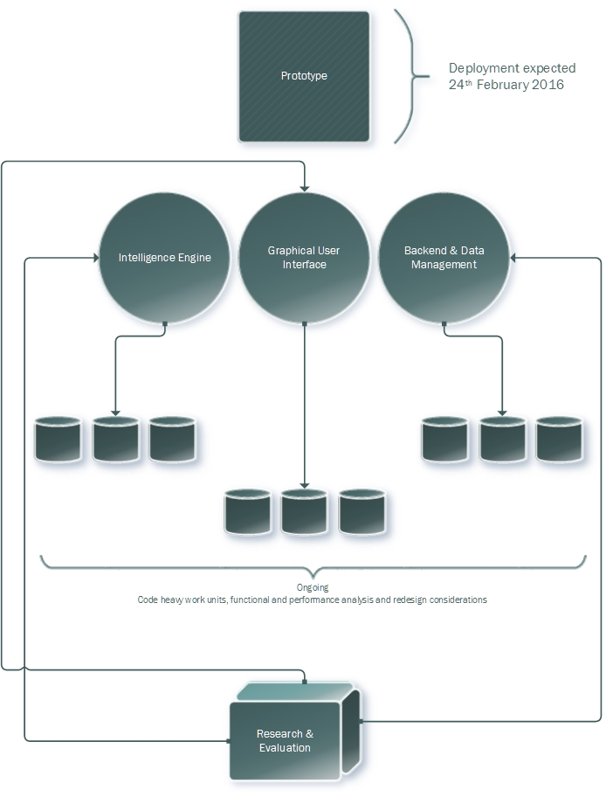

Figure 1- Concept of Strategic Delivery Management

# Scope

## Project Assumptions

* Player has basic understanding of the game of scrabble.
* Player can operate a computer and mouse with a minor degree of competency.
* Player can visually identify screen based alphabetic objects.

## Project Constraints

* Runs on windows operating system.
* .Net framework 4.0 or higher.

## Project Boundaries

* Game controlled by mouse interaction only.
* Maximum length of words is 10 characters.
* Only one letter on the board can be used for each turn.
* English open word list (EOWL) used by computer and used for player check and scoring.
* Highest scoring word always chosen by computer.
* One player vs the computer at a time
* Three different searching techniques to be tested and the most efficient to be implemented with the graphical user interface.
* XAML used for graphical interface design and C# used as logical programming language.

## Project Scope Description

### Game Scope

A graphical user interface is used to display the game board, the player(s) and the computer's scrabble tiles from a collection of tiles and the scoreboards. The player will be able to place tiles from their collection onto the board. If the word is valid the game will calculate the score of the word and add it to the player's total score. The computer will then place a word on the board using a single tile on the board. Its score will be calculated and added to its total.

If there is no more possible it is possible to replace tiles in the player's rack with random tiles from the collection of tiles. The computer will do this automatically. The game ends when there are no more tiles left in the bag or no more moves are possible due to insufficient space or tile combinations being insufficient to form a valid word. The player with the highest score at the end of the game wins.

### Search and Score Scope

For the player the letters places on the board are entered into an algorithm that will check the word against the dictionary of words in the games and checks if its valid. If it is valid the game will calculate the score based on the letters and the position on the board.

For each tile already placed on the board the computer will use it and all the other tiles in its rack to compute all possible words that are matched in the games dictionary. It will check if the word can be placed legally on the board. If it can be placed, the computer will calculate the score of the word based on letters and bonus positioning. The word with the largest score is placed on the board when all possibilities have been checked.

If there are no more possible moves for the player, then it is possible to exchange tiles in the player's rack for random tiles from the collection. This is done automatically by the computer. This procedure counts as a turn for either player. Enter details here about it being an illegal game choice to choose random tiles when there is a word available in the set of tiles? The computer checks before it distributes new tiles?

# Deliverables

## Strategic Deliverable (1)

Functional prototype developed from ongoing research on efficient algorithms and satisfactory GUI design. This deliverable will conform to the standards described within the project and success scoping regulations. Final documentation will also be considered a strategic deliverable.

## Operation Deliverables (3)

These are considered the key deliverables of the project. Each of the successful deliverables will have documentation artefacts also. These will be the physical workings of the project that can be tested and eventually demonstrated. The GUI, Principal Game/Intelligence Engine & Data Management system are the main components identified at this stage so far.  Documentation pertaining to each section of development will be considered a deliverable also, this will all later be merged to form the global document to identify the entire project.

s

# Functional Interfaces

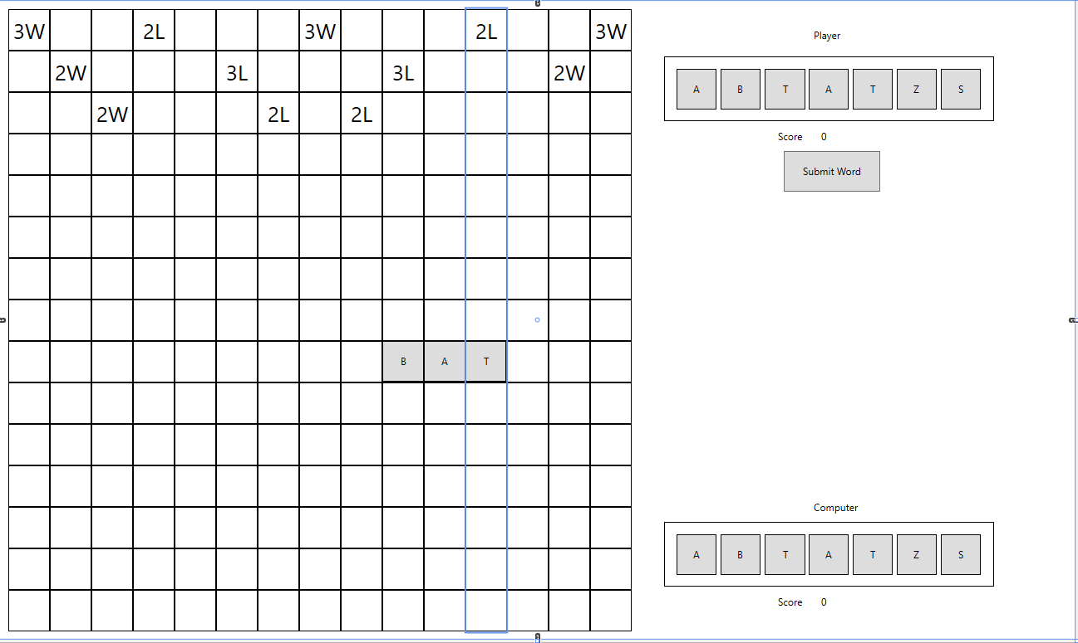

Figure 2 - Main Scrabble Game Board Prototype

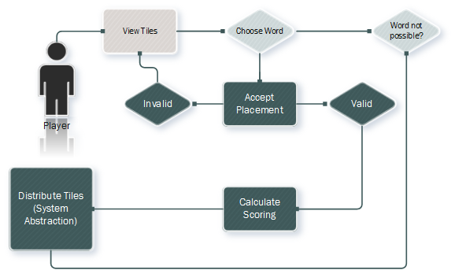

Figure 3 - User Functional Interface (Brief)

## Functional Interface (External)

Functionally, the project will accept only one mode of input from the user and only needs to accept one mode of input from the user. That is the mouse selected tile-word combination. The system will output a valid input as a calculated score.

## Functional Interface (Internal)

# Standards (Specific to Project)

## C# / .NET Framework Development Standards

Much of the project code base will adhere to MSDN .NET Framework Development standards. Included in this standard framework are governing rules the following disciplines:

* Naming Guidelines
* Type Design Guidelines
* Member Design Guidelines
* Designing for Extensibility
* Exception Design
* Usage Guidelines
* Common Design Patterns

## Data Modelling Standards & Normalisation

The Data Model supporting the back end of the project will adhere to database normalisation standards and complement relational algebraic rules of sets. IEEE defines various standards that can govern these rules and maintain correct modelling rules.

## Game Rules Standards

* The first player combines two or more of his or her letters to form a word and places it on the board to read either across or down with one letter on the centre square. Diagonal words are not allowed.
* Turn is completed when the score for that turn is calculated and the game refills the rack with as many new tiles as was played.
* Always keep seven letters on your rack, as long as there are enough tiles left in the bag.
* All letters played on a turn must be placed in one row across or down the board, to form at least one complete word.
* No tile may be shifted or replaced after it has been played and scored.
* Blanks: The two blank tiles may be used as any letters. When playing a blank, you must state which letter it represents. It remains that letter for the rest of the game.
* You may use a turn to exchange all, some, or none of the letters.
* The game ends when all letters have been drawn and one player uses his or her last letter or when all possible plays have been made.

# References

|  |  |
| --- | --- |
| [1] | Hasbro, “Scrabble Hasbro,” 04 10 2015. [Online]. Available: http://scrabble.hasbro.com/en-us. |
| [2] | “Merriam - Webster Scrabble,” Merriam - Webster, 04 10 2015. [Online]. Available: http://www.merriam-webster.com/game/scrabble.htm. [Accessed 04 10 2015]. |
| [3] | “The English Open Word List,” Dreamsteep, 04 10 2015. [Online]. Available: http://dreamsteep.com/projects/the-english-open-word-list.htm. [Accessed 04 10 2015]. |
| [4] | “Scrabble - The Pixie Pit,” The Pixie Pit, 01 10 2015. [Online]. Available: http://thepixiepit.co.uk/scrabble/dictions.htm. [Accessed 01 10 2015]. |
| [5] | A. W. A. &. G. J. JACOBSON, “The World's Fastest Scrabble Program,” *Communications of the ACM,* vol. 31, no. 5, 1988. |

# Table of Figures

Figure 1- Concept of Strategic Delivery Management 3

Figure 2- Main Scrabble Game Board Prototype 6

Figure 3- User Functional Interface (Brief) 6